دليل

تنزيل وتشغيل التطبيق

وإدارته واستخدامه

إعداد الطلاب
محمد أمير دليواتي Mohamed_amir_58826
محمد نظام Mohammad_57669

إشراف الدكتور: خليل عجمي

Contents
1. Installing Sedna 3
2. Running the program 7
3. Settings: 8
4. Upload / Export document 9
5. Manage Folders 11
6. Search: 13
7. Edit/Delete Document: 15
8. Add document: 16

Installing Sedna
Download sedna files from http://www.sedna.org/download.html
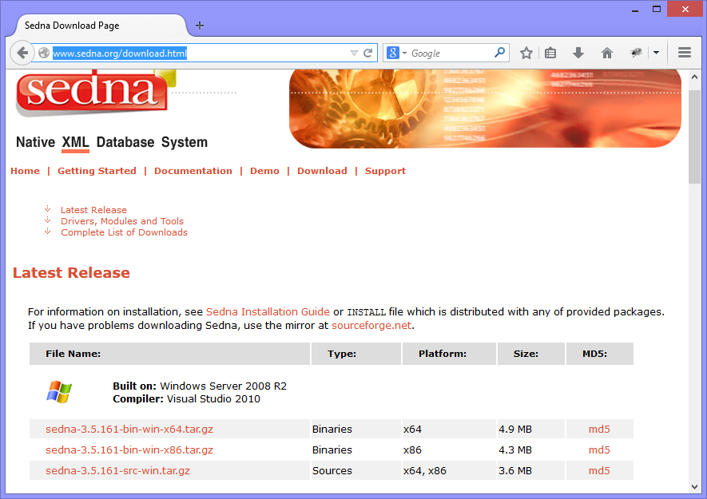
Choose the appropriate files according to your system (Windows 32bit or 64bit, Linux, Apple, …)

For Windows download the file and extract it to any folder ex: (E:\sedna)
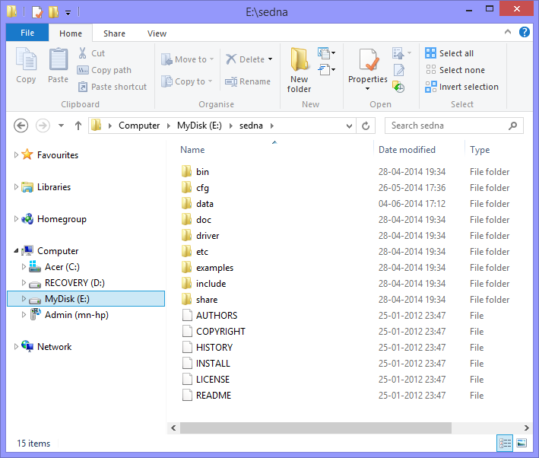

And make sure to add a reference to the bin directory in PATH, like this:
Open ‘System Properties’
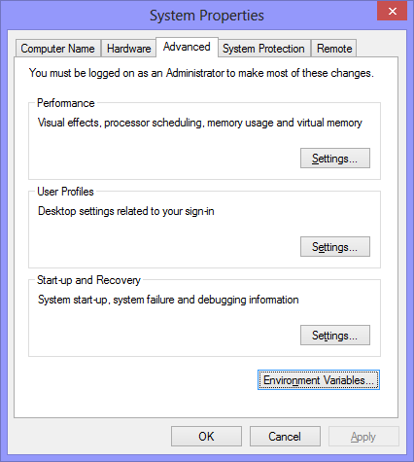

Click ‘Environment Variables’
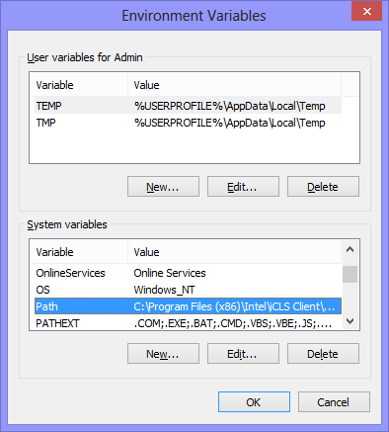
Select Path, then press Edit:
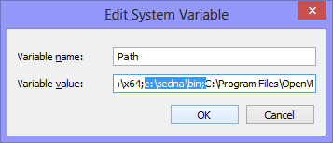
And add the bin folder, like above.

Running the program
Now we are ready to start the program, double click on the executable file.
When the program starts, it starts the Sedna and the database (As shown below)
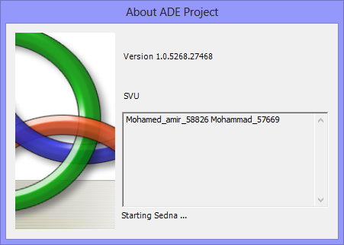
Then it will ask the user for name and password:
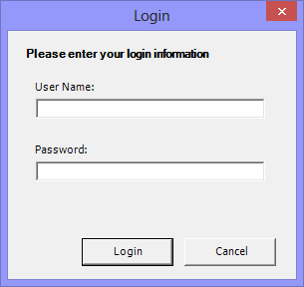
We have three kinds of users:
Normal User: (name: user, pass: user) Can see and search documents.
Admin: (name: admin, pass: admin) Can Add/Edit/Delete documents.
Super Admin: (name:superadmin, pass: superadmin) Can Create/Rename/Delete Folders, and upload XML Files to sedna.

Settings
The sittings page is allowed for SuperAdmin Only.
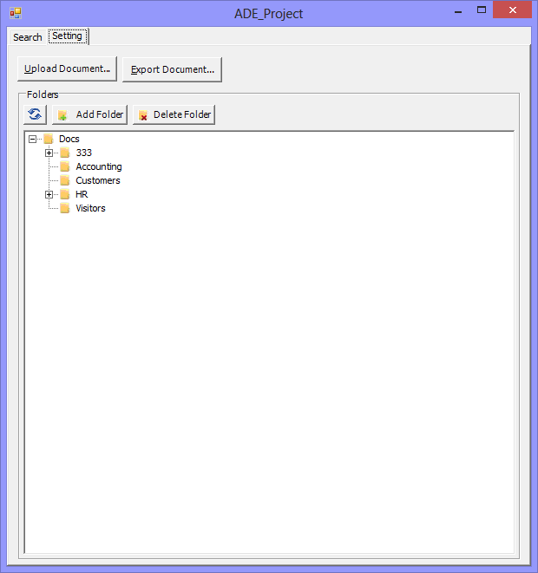

Upload / Export document
Here we can Upload XML Document to Sedna:
By Clicking on “Upload Document” and choose the XML File, By default the file will be in XMLData Folder, and its name is mydata.xml.
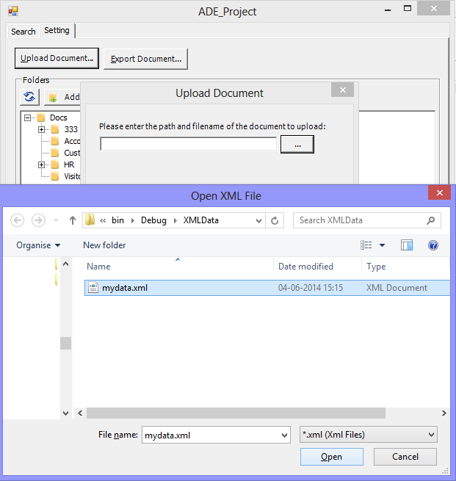
Choose this file and press Next
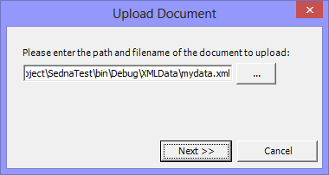
Then the file will be uploaded, and a notification message will show that:
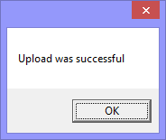

Also we can get the data from sedna to XML file by pressing the button Export Document:
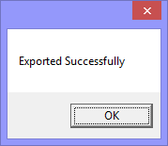

Manage Folders
Super Admin can also manage the folders: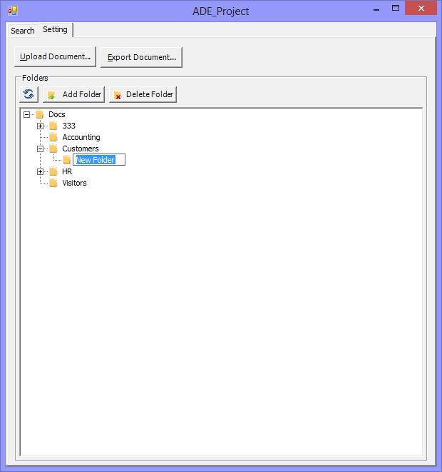
Be careful when deleting/renaming a folder, because the documents will not be updated
(this should be done in Version2)
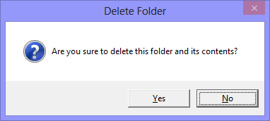
To Rename a folder just click it and press F2:
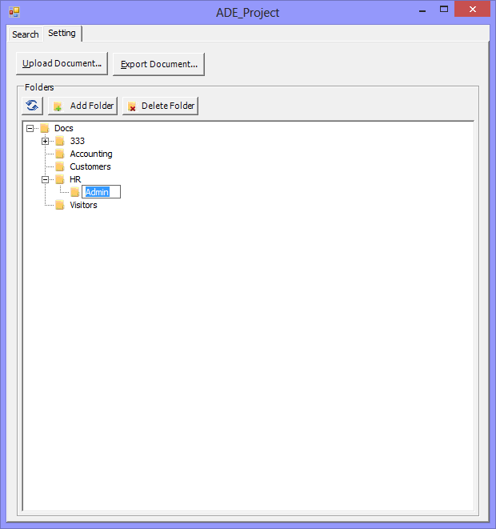

Search
To search for a document write its name (case insensitive) in the text box, and press Search button, a list of documents will appear in the grid, when you select a row, the details will be shown under the grid: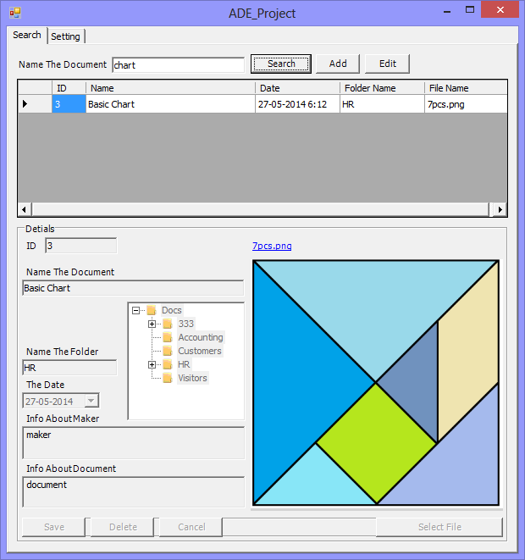

If the document is an image, then you can see a preview of it, if not you can click the link above the preview area to open the document using the associated program.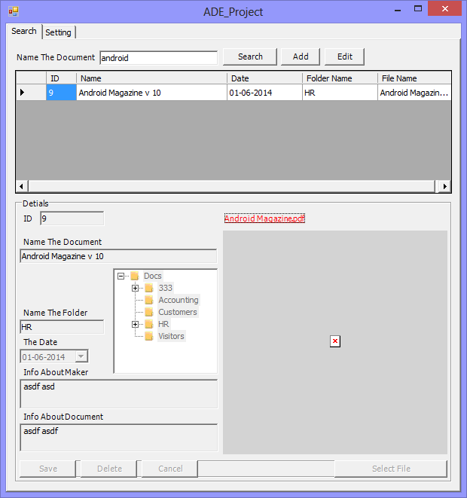

Edit/Delete Document
Search for the document and click on it to see it, then press Edit button. The document fields will be enable; you can either change the fields or delete the document.
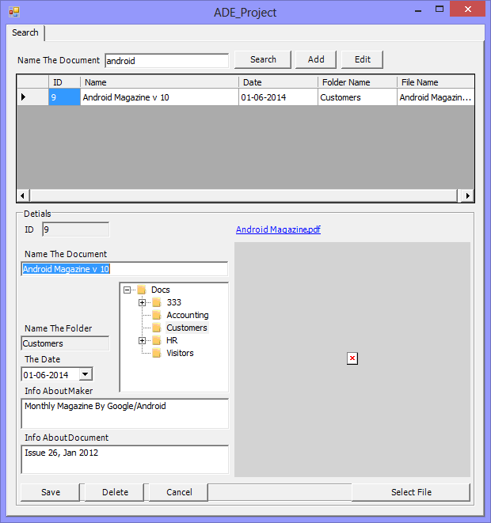

Add document
Press Add button to empty the fields and start to enter a new entry, fill in all fields and choose the file by pressing “Select File” button, then press “Save”. The document will have a new ID (Maximum ID plus 1) automatically.
